# **WIN up to £25 gift voucher!**

# **Name the bear competition**

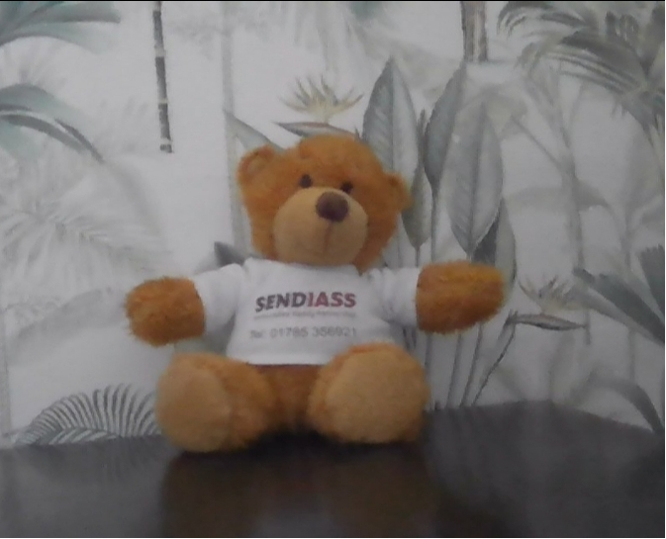

**A little brown bear went in search of some honey,**

**But they became lost and began to worry,**

**We found this brown bear and gave them a SENDIASS home,**

**They now need a name and that is where you come along.**

**Please name this bear and tell us their story,**

**How they became lost, what happened on their journey?**

**A winner will be chosen and will receive a bear too,**

**Along with a gift voucher especially for you!**

**SENDIASS Summer Competition -**

**Name the Bear**

**Open to ages 6-11 years for children with SEND in Staffordshire.**

**Please name the bear, draw a picture and write a short story about how they became lost and found their way to SENDIASS.**

**Ways to enter:**

**1. Use your own piece of paper to create your story and picture. Take a picture of this to email to us.**

**2.  Create your entry on a word document and attach this to your entry email.**

* Email your entries to [sfps@staffordshire.gov.uk](mailto:sfps@staffordshire.gov.uk) with the subject heading – SENDIASS Summer Bear Competition
* The winner receives a £25 gift voucher, 2 runners up winners get a £10 gift voucher, all 3 receive a bear.
* Entries must be received by the 4th of August 2025. Winners will be chosen on the 5th September 2025.

