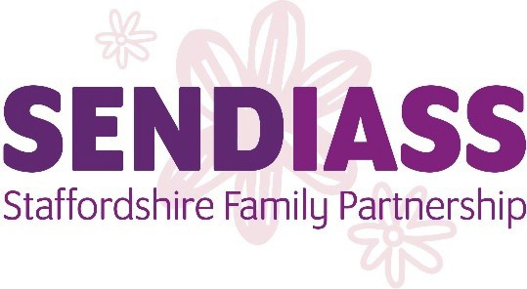

SENDIASS Staffordshire Family Partnership

Impartiality Policy
The Special Educational Needs and Disability Code of Practice (2014) states that
the Local Authority must provide an Information Advice and Support Service
(IASS) that provides parents, carers and children and young people with:
“Accurate, impartial, information on their rights, roles and responsibilities on
issues about education, health and social care which relate to their SEN or
Disability.”
SENDIASS Staffordshire Family Partnership (SFPS) provides the Staffordshire
Information, Advice and Support (IAS) Service, which is funded by
Staffordshire County Council (i.e. it is an “in house” service). It operates at “arms
length” from the Local Authority as an independent and confidential service for
both parents and carers of children (0-25 years) with special educational needs
and or a disability, and children and young people (0-25) with special educational
needs and or a disability.

SFPS aims to enable both parents and carers to become effective partners in their child or young person’s education, and children and young people to
become effective partners in their own education, by providing them with
impartial information and support to allow them to make informed decisions and to feel more confident in expressing their views.
Location

SFPS occupies its own offices, leased from the County Council, but separate from any other service within the LA.
Image/Identity

SFPS does not have to comply with County Council guidelines in respect of corporate identity; letter heading, logo etc.
It has its own logo and strap lines for use on leaflets and other publications.

Advisory Group

The Advisory Group exists to steer and monitor the work of the SFPS and works to agreed Terms of Reference.
The Group has representation from parents and carers’ of children and young people with SEND, SFPS staff, and Voice for Change Parent, Carer Group, CCG (Health), LA Head of Vulnerable Learner Services, Children’s Social Care and the Cabinet Member for Education and SEND, along with other parent and grandparent representatives.

The Group is chaired by a parent or carer to ensure its impartiality and independence from the LA.
Line Management

The SFPS Manager is line managed by the Commissioner for Access to
Learning. Regular meetings between the SFPS Manager and their line manager allow issues of concern to parents and carers to be raised. However, all
information is kept strictly confidential and no names are disclosed unless
parents have asked specifically for their named case to be raised.

Processes
SFPS has policies and procedures to ensure that impartiality underpins all its
activities and is covered during training and induction for all staff and volunteers.

Information, books and resources are held on site in the reference library.
Information is accessible for parents and is also used in staff induction and IPS training to make sure that the staff and volunteers are able to give impartial and neutral information.
External speakers are brought in, when appropriate, to input into team training
events and IPS training courses. Staff induction may include visits to partners
(both internal and external to the Local Authority) including local support groups
and others.
National Law training is undertaken by all advice and support providing staff to ensure that accurate information can be given to all parents.
Staff and volunteers are aware of the importance of outlining to parents, carers, children and young people the range of options open to them at a particular stage of their child’s education.
A system of monthly line management and My Performance Conversations has been established to include observation of practice and a sampling review of casework with all staff to ensure that this principle is adhered to.

Conflict of Interest
A member of staff would not, unless unavoidable, work with a parent in
circumstances where there could be a potential conflict of interest. If this
situation is unavoidable (e.g. no other staff member being available), then the parent is made aware and given alternative options.
Date of review: October 2020
Date of next review: October 2021

