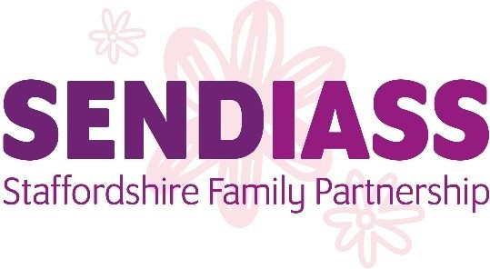

SENDIASS Staffordshire Family Partnership Equal Opportunities Policy
SENDIASS Staffordshire Family Partnership is committed to providing a service which is free from discrimination and prejudice and endeavours to meet the needs of all parents and carers of children with special educational needs and children and young people.

Through the Service Development Plan and ongoing review we will strive to
- develop and promote Service responses and practices which are fully inclusive and accessible for all
- ensure that the voice of all parents and carers of children with SEND is heard and has influence on the educational provision for their children
- ensure that the voice of all children and young people is heard and has influence on the educational provision for themselves.

We will:
- Adhere to and actively support the Staffordshire County Council’s Equal
Policy
- Challenge negative perceptions and behaviours which discriminate against any individual or group based on their age, race, religion/belief, disability, gender, gender reassignment, sexual orientation, pregnancy and maternity, marriage and civil partnership
- Respond to individual and group needs and concerns on the basis of respect, individuality and equality
- On identifying any special language or communication needs, take whatever steps are necessary to provide a consistent quality of service and information
- Ensure that service staff are made aware of this Equal Opportunities statement

Date of review: November 2023
Date of next review: November 2024

